Հավասար հայտարար ունեցող կոտորակների համեմատում
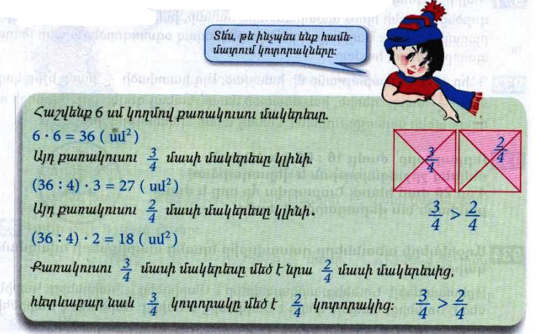
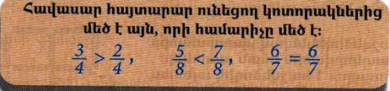
Դասարանական առաջադրանքներ
1․ Համեմատի՛ր
$$\frac{2}{5}>\frac{3}{5}$$

$$\frac{6}{17}< \frac{5}{17}$$

$$\frac{7}{123}= \frac{7}{123}$$

$$\frac{18}{19}= \frac{18}{19}$$
2․ Դասավորի՛ր կոտորակները․
Աճման կարգով
$$\frac{6}{17}, \frac{12}{17}, \frac{4}{17}, \frac{15}{17}, \frac{17}{17}, \frac{3}{17}$$
3.17, 4.17, 6.17, 12.17, 15.17, 17.17
3․Համեմատի՛ր
$$\frac{3}{5}մ > \frac{4}{5}մ$$
$$\frac{7}{10}կգ< \frac{4}{10}կգ$$
4․ 4500լ տարողությամբ ջրավազանը ամբողջությամբ լցված էր ջրով։ Այգեպանը այդ ջրի $\frac{2}{3}$ մասը օգտագործեց այգին ջրելու համար։ Քանի՞ լիտր ջուր մնաց ավազանում։ 4500:3=1500 1500x2=3000
5․ Ավտոմեքենան պետք է անցներ 180կմ ճանապարհ։ Ճանապարհի $\frac{2}{3}$ մասն անցնելուց հետո քանի՞ կիլոմետր կմնա նրան դեռ անցնելու։ 180:3=60 60x2=120
6․ 1 ժամում ծորակից լցվում է 6000լ տարողությամբ ջրավազանի $\frac{1}{4}$ մասը։ Նույն ծորակից որքա՞ն ջուր կլցվի ջրավազանը 2 ժամում։ 6000:4=1500 1500x1=1500 1500x2=3000
7․ Ուրբաթ օրը՝ ժամը 16։00-ին, Աննան մեկնեց շրջագայության և վերադարձավ 4օր 20ժամ հետո։ Շաբաթվա ո՞ր օրը և ժամը քանիսի՞ն նա վերադարձավ տուն։ երեքշաբթի 12:00
Տնային առաջադրանքներ
1․ Համեմատի՛ր
$$\frac{14}{18}> \frac{17}{18}$$

$$\frac{3}{7} և \frac{4}{7}$$
$$\frac{11}{28}< \frac{9}{28}$$

$$\frac{24}{143}< \frac{21}{143}$$

2․ Դասավորի՛ր կոտորակները․
Նվազման կարգով
$$\frac{31}{35}, \frac{17}{35}, \frac{4}{35}, \frac{22}{35} ,\frac{19}{35}, \frac{35}{35}$$
35.35, 31.35, 22.35, 19.35, 17.35, 4.35
3․Համեմատի՛ր
$$\frac{3}{20}լ > \frac{6}{20}լ$$

$$\frac{2}{15}ժ > \frac{4}{15}ժ$$

4․ 4500լ տարողությամբ ջրավազանը ամբողջությամբ լցված էր ջրով։ Այգեպանը այդ ջրի $\frac{2}{3}$ մասը օգտագործեց այգին ջրելու համար։ Քանի՞ լիտր ջուր օգտագործեց այգեպանը այգին ջրելու համար։ 4500:3=1500 1500x2=3000
5․ Ջրավազանում կար 8000լ ջուր։ Այգին ջրելու համար պապին օգտագործեց այդ ջրի երեք քառորդ մասը։ Որքա՞ն ջուր մնաց ջրավազանում։ 8000:4=2000 2000x3=6000
6․ Մայրիկը գնեց 12կգ շաքարավազ։ Նա այդ շաքարավազի $\frac{1}{3}$ մասն օգտագործեց ծիրաանի հյութ պատրաստելու համար, իսկ մնացած մասը՝ ելակի մուրաբայի համար։ Մայրիկը որքա՞ն շաքարավազ օգտագործեց ելակի մուրաբա պատրաստելու համար։ 12:3=4 4x1 12-4=8
7․ Երկու թվերի գումարը 650 է, իսկ տարբերությունը՝ 0։ Որո՞նք են այդ թվերը։ 325

