Մասերի համեմատումը
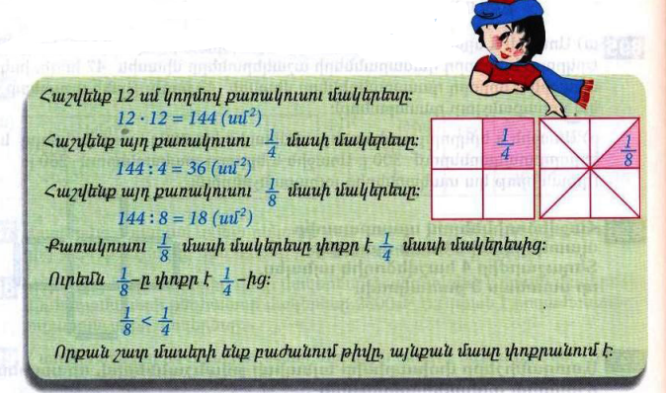
Դասարանական առաջադրանքներ
1․ Համեմատի՛ր։
$$\frac{1}{5}<\frac{1}{4}$$

$$\frac{1}{12}>\frac{1}{16}$$

$$\frac{1}{123}>\frac{1}{124}$$

$$\frac{1}{18}=\frac{1}{18}$$
2․ Թվերը դասավորիր
աճման կարգով․
$$\frac{1}{143}\frac{1}{142}\frac{1}{24}\frac{1}{16}\frac{1}{14}\frac{1}{9}$$
3․ 8400լ տարողությամբ երկու ջրավազաններից լցված են առաջինի $\frac{1}{4}$մասը և երկրորդի $\frac{1}{5}$ մասը։ Ջրավազաններից որու՞մ ավելի շատ ջուր կա։ Որքա՞ն է նրանցում եղած ջրի քանակների տարբերությունը։ 8400:4=2100 8400:5=1680 2100-1680=420
4․ Ջրավազանում կար 1250լ ջուր, որը կազմում է նրա տարողության $\frac{1}{4}$մասը։ Որքա՞ն է այդ ջրավազանի տարողությամբ։ 1250x4=5000
5․ Գտի՛ր անհայտ բաղադրիչը։
4938+2142=7070 7070-2142=4938
2014=3535-1521
6․ Ավտեմեքենան առաջին օրը գնաց 80կմ/ժ արագությամբ 5ժ, իսկ երկրորդ օրը՝ 85կմ/ժ արագությամբ 3ժ։ Որքա՞ն ճանապարհ անցավ ավտոմեքենան այդ երկու օրում։ 5x80=400 85x3=255 255+400=655
7․ Շախմատի խմբակում կա 11 տղա և 5 աղջիկ: Ամեն ամիս խմբակին միանում է 1 տղա և 3 աղջիկ: Քանի՞ ամիս անց խմբակում տղաների և աղջիկների քանակը կհավասարվի: 3
8․Ջրավազանում ջուր կարող է լցվել 2 խողովակներից: Առաջին խողովակով մեկ ժամում լցվում է 120լ ջուր, իսկ երկրորդով՝ 140լ: Քանի՞ լիտր ջուր կլցվի ջրավազանում 5 ժամվա ընթացքում, եթե խողովակները միաժամանակ բացվեն: 120x5=600 140x5=700 700+600=1300լ
Տնային առաջադրանքներ
1․ Համեմատի՛ր։
$$\frac{1}{7}>\frac{1}{9}$$

$$\frac{1}{28}<\frac{1}{16}$$

$$\frac{1}{143}=\frac{1}{143}$$

$$\frac{1}{19}>\frac{1}{27}$$
2․ Թվերը դասավորիր
նվազման կարգով
$$\frac{1}{8}\frac{1}{9}\frac{1}{12}\frac{1}{16}\frac{1}{216}\frac{1}{220},$$

3․ Մարդատար ավտոմեքենան 1 ժամում անցավ 240կմ երկարությամբ ճանապարհի $\frac{1}{3}$մասը, իսկ բեռնատարը՝ $\frac{1 }{4}$ մասը։ Ավտոմեքենաներից ո՞րն է 1 ժամում ավելի շատ ճանապարհ անցել։ Քանի՞ կիլոմետր ճանապարհ դեռ պիտի անցնի նրանցից յուրաքանչյուրը։ 240:3=80 240:4=60
4․ Ջրավազանում կար 2400լ ջուր, որը կազմում է նրա տարողության $\frac{1}{3}$ մասը։ Դեռ որքա՞ն ջուր կարելի է լցնել այդ ջրավազանը։ 2400x3= 7200 7200-2400=4800
5․ Գտի՛ր անհայտ բաղադրիչը։
21021=18018+3003
40735-8507=32328
6․ Երբ Հայկն իր գումարից 150դրամ տվեց Արային և 250դրամ՝ Գագիկին, նրանց ունեցած գումարները հավասարվեցին։ Որքա՞ն դրամ ուներ տղաներից յուրաքանչյուրը, եթե նրանք միասին ունեին 2400դրամ։ 2400:3=800 800-150=650 800-250=550 250+150+800=1200

